Project Title
Amazon Music Clustering Using Unsupervised Machine Learning
Skills take away From This Project:
Data exploration, Data cleaning, Feature selection, Data normalization, K-Means clustering, Elbow method, Silhouette score, PCA (optional), Cluster visualization, Genre inference, Python (pandas, NumPy), scikit-learn ,Data storytelling
Domain:
Music Analytics / Unsupervised Machine Learning
Problem Statement :
With millions of songs available on platforms like Amazon, manually categorizing tracks into genres is impractical. The goal of this project is to automatically group similar songs based on their audio characteristics using clustering techniques. By analyzing patterns in features such as tempo, energy, danceability, and more, learners will develop a model that organizes songs into meaningful clusters, potentially representing different musical genres or moods—without any prior labels.
Abstract
This study applies unsupervised machine learning techniques to segment Amazon Music tracks based on audio features such as danceability, energy, speechiness, acousticness, instrumentalness, tempo, and valence. Using K-Means clustering, songs were grouped into four distinct clusters representing different musical profiles. Dimensionality reduction techniques such as PCA and t-SNE were used for visualization. The clustering results were evaluated using Silhouette Score, Davies-Bouldin Index, and Inertia. The final clusters reveal meaningful musical categories such as high-energy party tracks, instrumental music, speech-dominant tracks, and acoustic emotional songs.
Objectives
- Explore and preprocess Amazon Music dataset
- Normalize audio features
- Apply K-Means clustering
- Identify optimal number of clusters
- Visualize and interpret song clusters

Methodology

  - Data Exploration & Preprocessing
    - Load the single_genre_artists.csv dataset into a Pandas DataFrame.

    - Audio features describing song characteristics
RangeIndex: 95837 entries, 0 to 95836
Data columns (total 23 columns):
# Column Non-Null Count Dtype
--- ------ -------------- -----
0 id_songs 95837 non-null object
1 name_song 95837 non-null object
2 popularity_songs 95837 non-null int64
3 duration_ms 95837 non-null int64
4 explicit 95837 non-null int64
5 id_artists 95837 non-null object
6 release_date 95837 non-null object
7 danceability 95837 non-null float64
8 energy 95837 non-null float64
9 key 95837 non-null int64
10 loudness 95837 non-null float64
11 mode 95837 non-null int64
12 speechiness 95837 non-null float64
13 acousticness 95837 non-null float64
14 instrumentalness 95837 non-null float64
15 liveness 95837 non-null float64
16 valence 95837 non-null float64
17 tempo 95837 non-null float64
18 time_signature 95837 non-null int64
19 followers 95837 non-null float64
20 genres 95837 non-null object
21 name_artists 95837 non-null object
22 popularity_artists 95837 non-null int64
dtypes: float64(10), int64(7), object(6)
memory usage: 16.8+ MB

- Text columns removed:
id_songs, name_song, id_artists, release_date, genres, name_artists
- Data Normalization
  - Use StandardScaler or MinMaxScaler to bring all features to the same scale. Clustering is distance-based, so feature scaling is crucial.
  - Loudness & tempo dominate without scaling
- Feature Selection
Danceability, energy, loudness, speechiness, acousticness, instrumentalness, liveness, valence, tempo, duration_ms

- Elbow Method
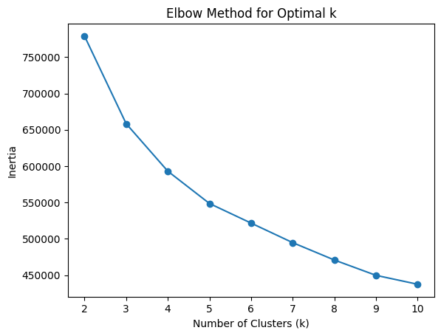
Elbow around k = 4 or 5 indicates optimal balance.”
- Silhouette Score
  - k=2, Silhouette Score=0.203
  - k=3, Silhouette Score=0.242
  - k=4, Silhouette Score=0.231
  - k=5, Silhouette Score=0.186
  - k=6, Silhouette Score=0.186
  - k=7, Silhouette Score=0.165
  - k=8, Silhouette Score=0.172
  - k=9, Silhouette Score=0.172
  - k=10, Silhouette Score=0.159
    - Pick highest silhouette score
    - 0.23106641264473862
- davies_bouldin_score
  - Lower DB score = better clustering
1.5296828507168276
- Inertia
  - (for K-Means): Measures cluster compactness.
- Dimensionality Reduction
  - Reduce the dataset to 2 or 3 components to visualize clusters later
- PCA Visualization
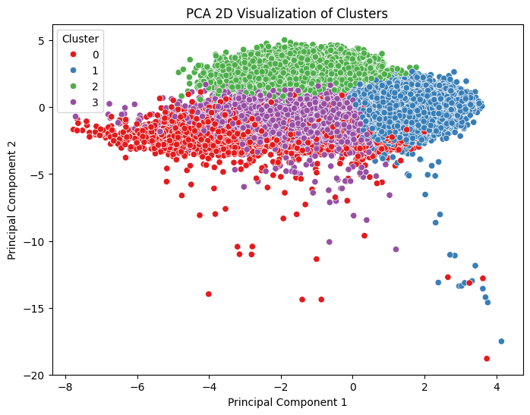
PCA (Principal Component Analysis): Helps reduce dimensions while preserving variance.

t-SNE:
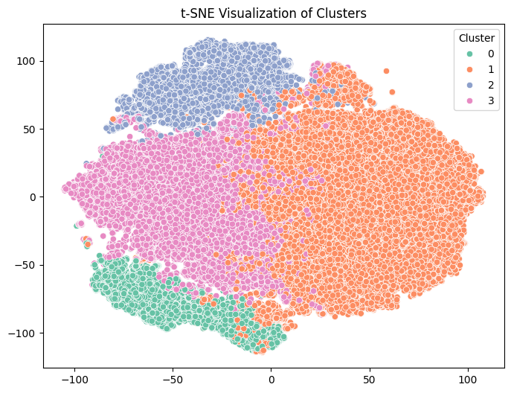
Captures complex relationships better but is computationally heavier.

- Visualize distributions of key features to understand variation in values.
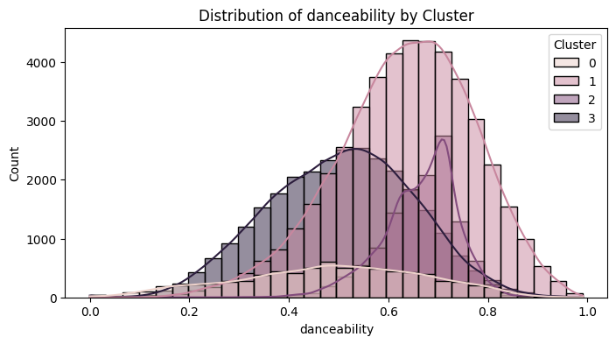

What the Image Shows:
- Most songs are concentrated in the medium to high danceability range (0.5–0.8).
- Few tracks exist in very low danceability (< 0.3).
Interpretation:
- The dataset is dominated by rhythm-friendly and groove-based songs.
- Highly danceable tracks are likely pop, commercial, or upbeat genres.
- Lower danceability songs may represent classical, ambient, or slow emotional tracks.

What the Image Shows:
- Large concentration in the medium to high energy (0.6–0.9) range.
- Fewer low-energy songs.
Interpretation:
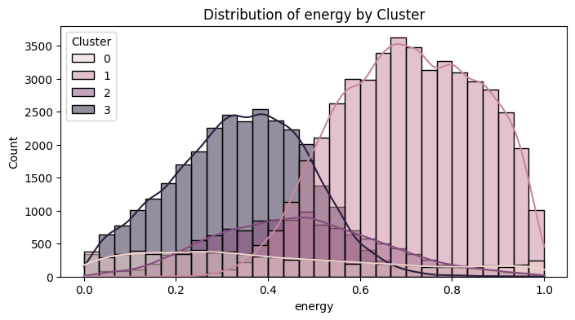
- The dataset mainly contains energetic tracks.
- High energy songs are likely party, EDM, rock, or commercial pop.
- Low energy songs may represent instrumental or acoustic music.

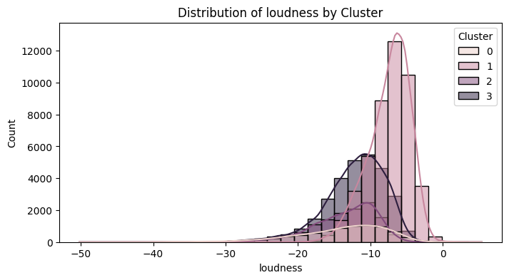
What the Image Shows:
- Most songs cluster around -5 dB to -10 dB.
- Very few extremely quiet tracks.
Interpretation:
- Modern music production trend: louder mastering.
- Tracks are professionally mixed and commercially produced.
- Loud songs usually correlate with high energy.

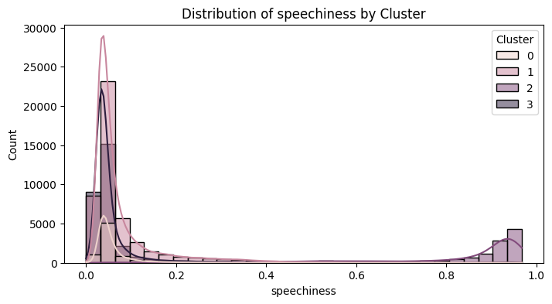
What the Image Shows:
- Majority of songs have low speechiness (< 0.3).
- Small peak near very high values (around 0.9–1.0).
Interpretation:
- Most songs are melodic with singing rather than spoken word.
- The small high-speechiness spike likely represents:
  - Rap / Hip-hop
  - Spoken word
  - Dialogue-heavy tracks
- This feature clearly separates rap-based clusters.

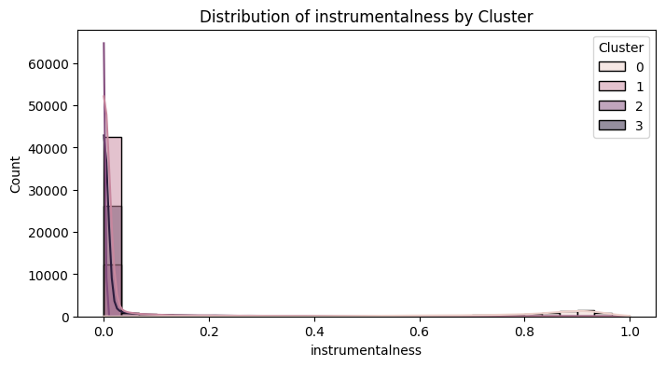
What the Image Shows:
- Most tracks have very low instrumentalness (near 0).
- Small group has very high instrumentalness (> 0.8).
Interpretation:
- Majority of dataset contains vocals.
- High instrumentalness tracks likely represent:
  - Classical
  - Background scores
  - Lo-fi / ambient
- This feature helps isolate instrumental cluster.

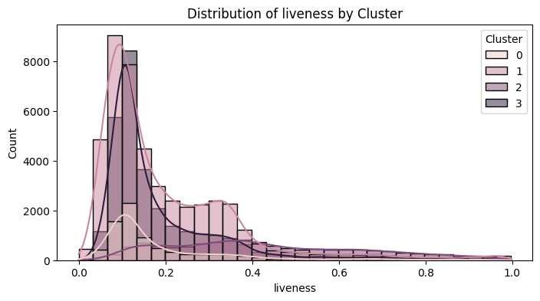

What the Image Shows:
- Most songs have low to moderate liveness.
- Few songs show high liveness (> 0.7).
Interpretation:
- Majority are studio recordings.
- High liveness tracks likely represent:
  - Live concerts
  - Acoustic sessions
  - Recorded audience performances

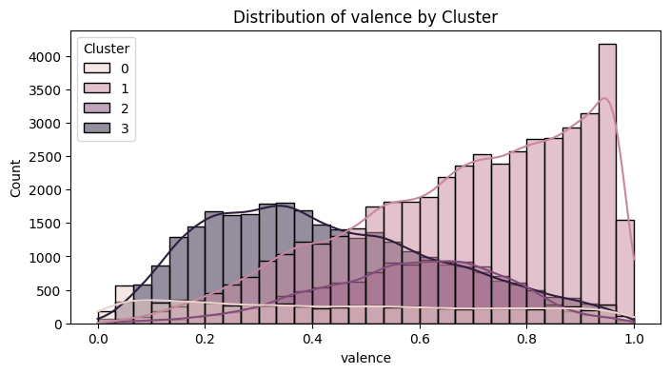

What the Image Shows:
- Spread across full range.
- Slight concentration in mid-range (0.4–0.7).
Interpretation:
- Dataset contains both happy and sad songs.
- High valence → cheerful, upbeat music.
- Low valence → emotional, sad, darker tone.
- This feature helps define emotional clusters.

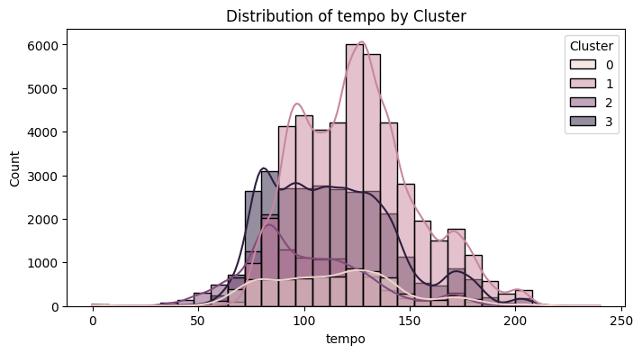
What the Image Shows:
- Most songs fall between 90–140 BPM.
- Few very slow (<70 BPM) or very fast (>170 BPM).
Interpretation:
- Dataset reflects mainstream tempo range.
- 100–130 BPM = pop & dance music dominance.
- Extreme tempos may represent special genres.

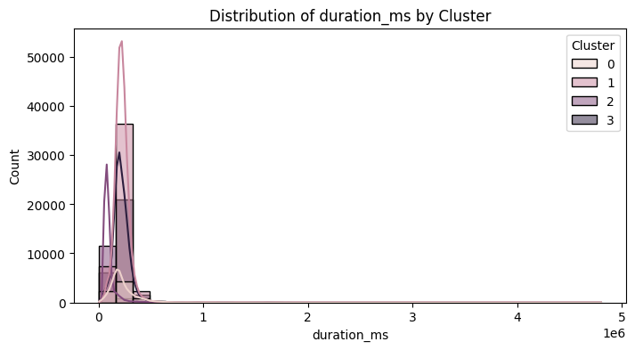
What the Image Shows:
- Most songs are between 180–300 seconds (3–5 minutes).
- Few long-duration tracks.
Interpretation:
- Typical commercial song length.
- Longer tracks may represent:
  - Instrumentals
  - Classical
  - Extended mixes
Overall Insight from All Images
- Dataset is dominated by commercial, energetic, vocal-based songs.
- A smaller segment represents:
  - Instrumental tracks
  - Rap/spoken tracks
  - Emotional or low-energy songs
These distributions justify why clustering separated songs into:
- Energetic Pop Cluster
- Instrumental Cluster
- Rap/Speech Cluster
- Emotional/Alternative Cluster
Feature | Cluster 0 | Cluster 1 | Cluster 2 | Cluster 3
Energy | Low | Highest | Moderate | Lowest
Instrumentalness | Very High | Very Low | Near Zero | Very Low
Speechiness | Low | Low | Extremely High | Low
Acousticness | High | Low | Moderate | Highest
Valence | Neutral | Highest (Happy) | Moderate | Lowest
Duration | Normal | Normal | Shortest | Normal

Visualization
Heatmaps comparing features across clusters.
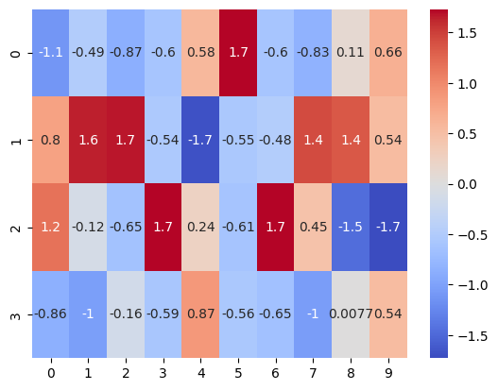
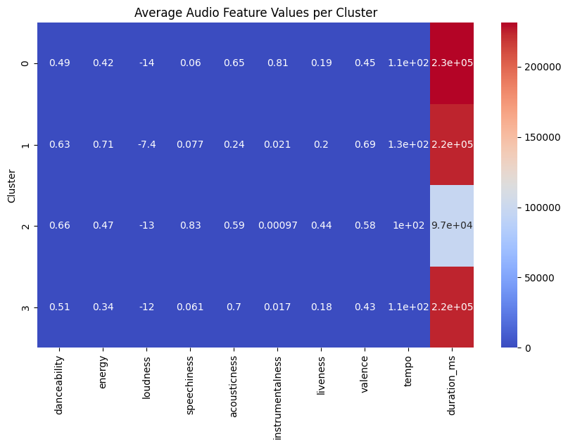

visualizes the average feature values of each cluster using a heatmap.
Instead of reading numbers in a table, we use colors to quickly compare patterns across clusters.
heatmap shows the average audio feature values per cluster. The coolwarm color scale helps visually identify high and low feature intensities, making it easier to interpret the characteristics of each cluster
  - Blue = Low value
  - Red = High value
  - White/light color = Medium value

- If Cluster 0 has red in energy and danceability → It’s energetic music.
- If Cluster 2 has red in instrumentalness → It’s instrumental music.

Cluster Evaluation
Cluster 0 Interpretation -lable: Instrumental / Acoustic Focus Music
Values:
- Danceability: 0.49 (moderate)
- Energy: 0.42 (medium)
- Loudness: -14 (lower volume)
- Acousticness: 0.65 (high)
- Instrumentalness: 0.81 (very high)
- Tempo: 110 BPM
- Valence: 0.45 (neutral mood)
Meaning:
- Very high instrumentalness
- High acousticness
- Moderate tempo
- Low loudness

Cluster 1 Interpretation - Label: Party / Dance Pop Music

Values:
- Danceability: 0.63 (high)
- Energy: 0.71 (high)
- Loudness: -7.4 (loud)
- Acousticness: 0.24 (low)
- Instrumentalness: 0.021 (very low)
- Valence: 0.69 (positive mood)
- Tempo: 130 BPM
Meaning:
- Energetic
- Danceable
- Vocal-based (low instrumentalness)
- Positive feeling

Cluster 2 Interpretation- Label:
Podcast / Spoken Word / Rap-heavy Content
Values:
- Danceability: 0.66
- Energy: 0.47
- Acousticness: 0.59
- Instrumentalness: 0.00097 (almost zero)
- Speechiness: 0.83 (VERY HIGH)
- Tempo: 100 BPM
Meaning:
- Extremely high speechiness
- Very low instrumentalness
- Moderate energy
High speechiness = strong spoken content.
Cluster 3 Interpretation - Label: Chill Acoustic / Soft Pop
Values:
- Danceability: 0.51
- Energy: 0.34 (low)
- Acousticness: 0.70 (very high)
- Instrumentalness: 0.017 (low)
- Valence: 0.43 (neutral)
- Tempo: 110 BPM
Meaning:
- Very acoustic
- Calm energy
- Vocal-based
- Soft profile

Cluster | Defining Feature | Overall Mood | Likely Genre Type
0 | Very high instrumentalness | Calm / Atmospheric | Instrumental / Ambient
1 | High energy + high valence | Happy / Party | Pop / Dance
2 | Extremely high speechiness | Lyrical / Rap-focused | Hip-hop / Spoken
3 | Moderate everything, lower valence | Emotional / Indie | Alternative / R&B

Business Use Cases
Personalized Playlist Curation: Automatically group songs that sound similar to enhance playlist generation.
Improved Song Discovery: Suggest similar tracks to users based on their preferred audio profile.
Artist Analysis: Help artists and producers identify competitive songs in the same audio cluster.
Market Segmentation: Streaming platforms can use clusters to analyze user listening patterns and optimize recommendations or promotions.

